Chapter 16, Problem 41.

Find the output voltage v_{o}(t) in the circuit of Fig. 16.64.

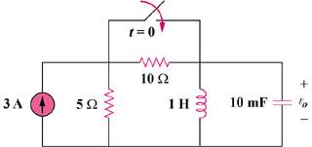

Figure 16.64
For Prob. 16.41.

